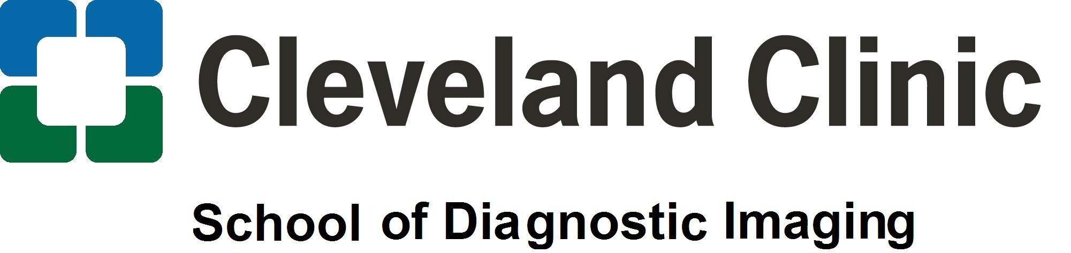

Magnetic Resonance Imaging (MRI) Program

The School of Diagnostic Imaging, Cleveland Clinic Health System, offers a certificate program in Magnetic Resonance Imaging (MRI) based on 16 months (4 semesters) of full time study. Students who successfully complete the program are eligible to apply for the national registry examination offered by the American Registry of Radiologic Technologists (ARRT). All students must have an associate degree or higher to take the ARRT Examination.

Admission Requirements
The following college-level credit bearing coursework must be completed with a grade of “C” or better by February 1st to be considered for acceptance:
- Anatomy & Physiology I & II
  - or Anatomy & Physiology for Medical Imaging from Tri-C
- Medical Terminology
- Associate degree or higher

Admission Process
The School of Diagnostic Imaging uses a selective process to determine which students will be accepted into the MRI Program. Acceptance is based on a point system from high school and college GPA, science and math classes and a behavior based interview. To be considered for acceptance into the MRI Program please be aware of the following steps:

- Complete the prerequisite college credit courses as indicated under Admission Requirements.
- Fill out the MRI Program Application available at www.clevelandclinic.org/sodi
- Send your application to the Program Director with a $20.00 acceptance fee.
- Have your official High School and College transcripts sent directly to the school.
- After submission of the above, we will contact you to complete a mandatory 8 hour observation at a Cleveland Clinic hospital.
- Deadline for application submission is February 1st each year.
- Behavior based interviews will be scheduled in February / March for applicants who have met the previous qualifications.
- Letters regarding program acceptance will be e-mailed out approximately one month after the interview process has been completed.
- The MRI Program starts each year in August.

Tuition & Fees
Program Tuition | $12,000

Clinical Sites
Akron General Hospital – Cleveland Clinic Hillcrest Hospital – Cleveland Clinic
Cleveland Clinic Foundation & Family Health Centers Medina Hospital – Cleveland Clinic
Euclid Hospital – Cleveland Clinic Lutheran Hospital – Cleveland Clinic
Fairview Hospital – Cleveland Clinic South Pointe Hospital – Cleveland Clinic

Questions? Call Gloria Albrecht MS, RT(R) - Program Director at 216.692.7512 - galbrech@ccf.org or

Halley Majersky BS, RT(R)(M)(CT)(MR) – CT/ MRI Coordinator at 216.692.7523 - majersh@ccf.org
Kimberly Saghy BS, RT(R)(CT)(MR) CT/MRI Instructor at 216.692.7889 – ksaghy@ccf.org

